**ISSIO Solution – Chess board/piece movements Coding Challenge.**

Chess is a very popular game, and almost everybody knows at least the basic moves of pieces on the board. You don’t have to be a grandmaster to be able to code in this challenge.

All we are doing is just implementing the moves of two pieces: Bishop and Rook.

**Bishops** can move diagonally on the board in any direction. **Rooks** can move only vertically or only horizontally.

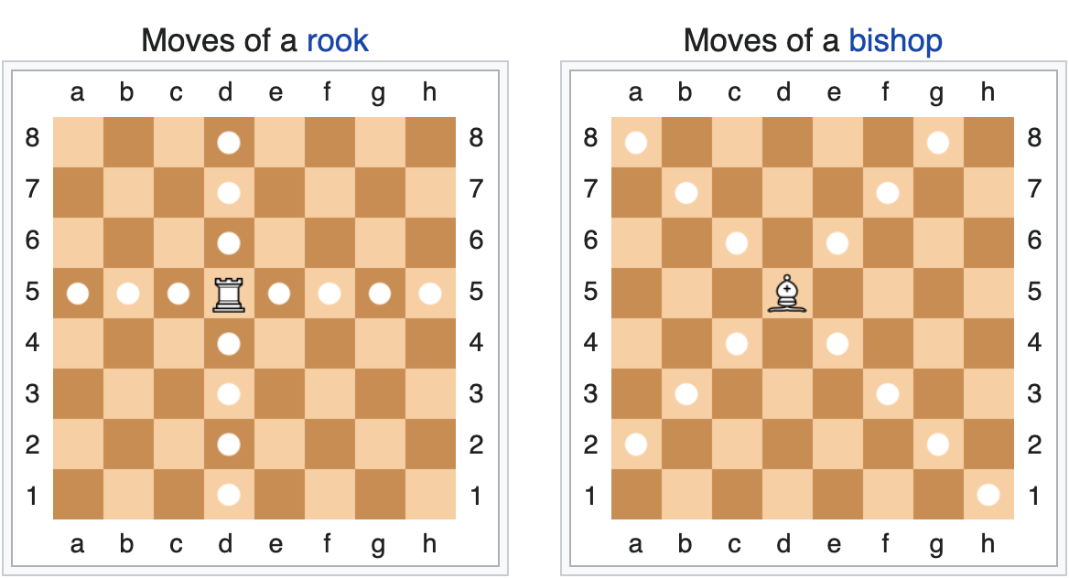

You can review the rules and the moves here: <https://en.wikipedia.org/wiki/Chess#Movement>

You will be provided with the sample code that creates the table and sets up some pieces (black and white) as shown on the diagram:

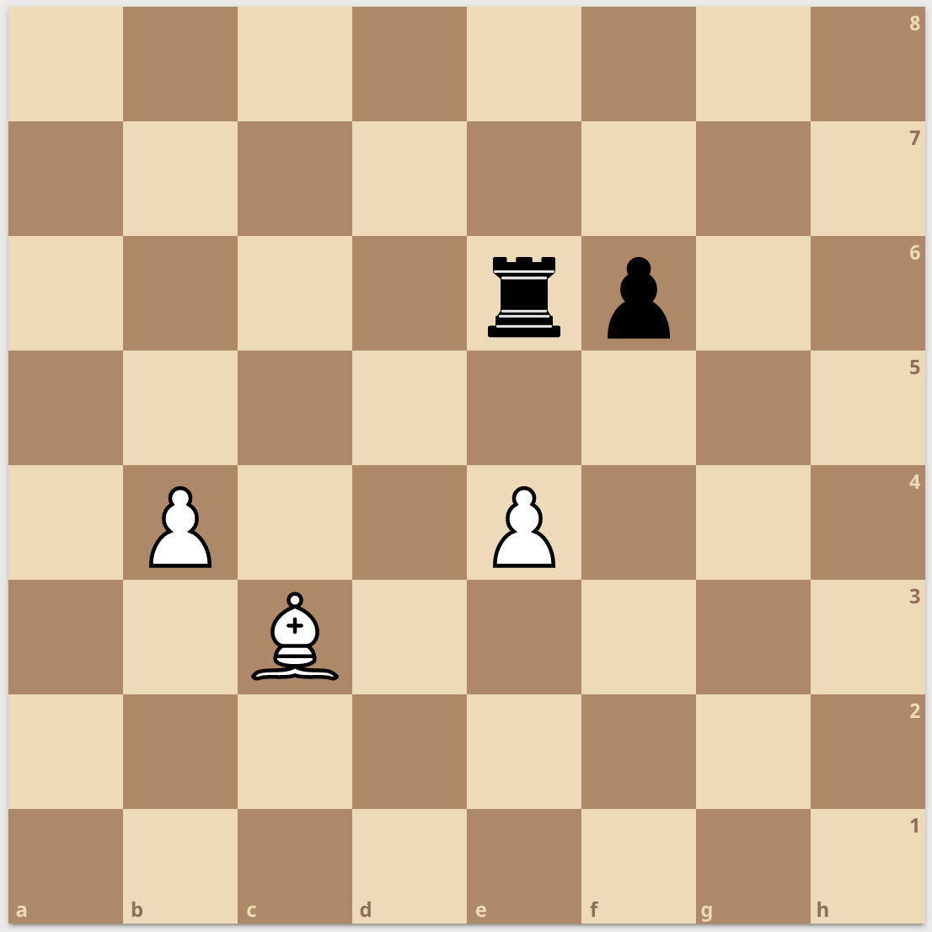

Your goal is to implement the move of the Bishop (E3) and the Rook (E6). For example:

> $board->makeMove(['c', 3], ['e', 1])

You take a piece in the square C3 and try to move it to E1. If the chess piece from C3 square can make a successful move to E1, the method will return **true**. If the move is illegal, it should indicate so. You will have to take into consideration all legal and illegal moves.

The base code is provided in both PHP and JavaScript. You can use **either one** (your choice). Feel free to adjust all of the classes and/or adding additional methods.

You need to document your code and cover the edge cases, which are **listed at the end of the “ChessChallenge” PHP or JS files**. You should not spend more than 1-2 hours on the exercise.

Your performance will be measured on your ability to work with the existing code, follow the instructions and demonstrate an understanding of the principles and concepts of Object-Oriented Programming.

The code should be executed from the command line:

> node ChessChallenge.js # for node 14 and above

> php ChessChallenge.php # for php7

Feel free asking any questions. Good luck!